**Center for American Education: American Degree Transfer Program**

“Studying abroad expands personal horizons and brings new perspectives to life which makes you more employable in today’s globalized world. Studying at Sunway University provides a seamless pathway towards an exceptional American educational experience”

**Hallmarks of American Education**

* Holistic and well-balanced curriculum
* Broad-based education with a wide range of academic disciplines
* Interactive approach to learning

American-style education enables students to immerse themselves in holistic learning experiences - combining interactive intellectual endeavors with creative extra-curricular pursuits. Students actively participate in community work, industry exposure, academic forums, leadership development, workshops, sports and extra-curricular activities.

**Intakes:** January, March, June & August

***Entry Requirements***

**ADTP (Science / Engineering) — For Science, Engineering, Aviation, Computer Science or related majors**

SPM / O-Level: Pass with minimum 5 credits (including English & Mathematics or any Science subject)

UEC: Pass with minimum 5 Grade Bs (including English & Mathematics or any Science subject)

Other Qualifications: Any other qualification will be considered on a case-to-case basis

**ADTP (Arts) — For Business, Communication, Liberal Arts or related majors**

SPM / O-Level: Pass with minimum 5 credits (including English)

UEC: Pass with minimum 5 Grade Bs (including English)

Other Qualifications: Any other qualification will be considered on a case-to-case basis

**English Language Requirements:**

IEP: Level 4

Cambridge English (First): 50 and above

**Education Pathway**



**A Flexible Credit Transfer System**

One of the key strengths of studying in ADTP is that students can customize their education pathways by choosing one of Sunway University’s transfer arrangements of 1+3, 2+2 or 3+1* years. Students are able to transfer their credits to a university of their choice where they will specialize in their chosen field.

*coming soon in 2016

**A Global World-Class Transfer Degree**

Sunway’s ADTP has an impressive record as **over** **80% of students transferred to U.S. are in the Tier 1 Universities.** Students have successfully transferred to renowned universities in the U.S. including Cornell University, New York University, University of Michigan – Ann Arbor, Boston University, and many more. The flexibility of this program also allows students to transfer to universities in Canada, the UK, New Zealand and Australia.

**Selection of over 1,000 majors**

With over 1,000 majors available in the U.S., students can choose from a diverse range of study options:

Engineering · Aviation · Business · Psychology · Communication · Geology · Forensic Science · Actuarial Science · Architecture · Sciences · History · Sociology · Political Science · Theatre Performance and more.

**Excellent Student Support Services**

**Mentor-Mentee Program**

Our dedicated and qualified faculty offers personal attention, mentoring and guidance. Each student is assigned to an Academic Advisor who provides academic guidance and keep close tabs on the student’s progress. Students can count on a high standard of education because of our small class sizes and highly supportive faculty who has the passion to teach and care about the future of their students.

**Dedicated University Guidance Services**

Students get personalized guidance from our U.S.-trained placement expert with strong support from International Office University Placement (IOUP). Students receive professional advice on transfer options, assistance in university applications, and information on reference materials and resources.

Regular workshops are conducted to keep students informed on Pre-application criteria, Visa Application, preparation of Recommendation Letter, Pre-Departure arrangements and other application processes and requirements.

**Post-Transfer Services**

**Summer Courses**

Summer is a great time for ADTP transferred students to participate in our summer courses. Students will have the opportunity to complete their General Education requirements or study exciting course topics offered during these sessions. Students will have closer interaction with their lecturer and fellow students in a smaller-size class.

**Proctor Service**

We offer free proctoring services to ADTP transferred students who are taking online courses to fulfill their exam requirements during the summer semester.

**Internship Experience**

Internships are a great platform to prepare students for the real world. They are able to explore potential careers, network with professionals and gain valuable job knowledge. Sunway’s ADTP offers many internship opportunities in diverse industries through the arrangements with Industrial Advisory Board members.

**Liberal Arts Courses / General Education Requirements**

Liberal arts courses, commonly known as the general education requirements, vary between universities. Students are recommended to take between 3 and 9 credits from each area. The suitable number of credits to be taken must be mapped according to the intended transfer universities’ requirements.

**Area 1: Arts & Humanities**

|  |
| --- |
| ENGL 1023 Film Appreciation |
| HIST 1013 Multicultural America |
| HIST 1023 U.S. History to 1877 * |
| HIST 3013 Intellectual History of the Modern West |
| PHIL 1013 Introduction to Philosophy |
| RELS 1013 Survey of World Religions * |
| THEA 1013 Introduction to Theatre |

**Area 2: Quantitative Reasoning**

|  |
| --- |
| ACCT 2013 Basic Principles in Accounting |
| ACCT 2023 Management Accounting |
| FINN 3013 Business Finance |
| MATH 1013 Finite Mathematics |
| MATH 1014 College Algebra * |
| MATH 1024 Pre-calculus |
| MATH 1034 Calculus I |
| MATH 1044 Calculus II |
| MATH 1053 Discrete Mathematical Structure |
| MATH 2014 Calculus III |
| MATH 3014 Differential Equation |
| MATH 3024 Linear Algebra |
| STAT 2013 Introduction to Statistics |
| STAT 2023 Statistics for Engineering |
| STAT 2034 Probability and Statistics |

**Area 3: Science & Technology**

|  |
| --- |
| BIOL 1013 General Biology |
| BIOL 1033 Introduction to Cell Biology |
| BIOL 1053 Evolution, Diversity & Ecology |
| BIOT 1043 Introduction to Biotechnology |
| CHEM 1013 Chemistry and Society |
| CHEM 1033 General Chemistry I |
| CHEM 1053 General Chemistry II |
| CHEM 2013 Organic Chemistry I * |
| CSCI 1013 Introduction to Computer Applications |
| CSCP 1014 Programming I |
| CSCP 2014 Programming II |
| CSCP 2024 Data Structures * |
| EENG 2014 Circuit Analysis |
| ENGR 1013 Fundamentals of Engineering |
| ENGR 2013 Basic Statistics for Engineering |
| ENGR 2023 Dynamics for Engineers |
| ENGR 2033 Fundamentals of Thermodynamics |
| ENGR 2043 Material Science * |
| ENGR 2053 Mechanics of Materials * |
| ENGR 2064 Digital Logic * |
| ENVS 1014 Introduction to Environmental Studies |
| MLAB 1011 Introduction to MATLAB |
| PHYS 1014 College Physics I |
| PHYS 1034 College Physics II |
| PHYS 2014 Physics 1 |
| PHYS 2034 Physics 2 |

**Area 4: Behavioral & Social Sciences**

|  |
| --- |
| BU.S.N 1013 Introduction to Business |
| COMM 1023 Introduction to Human Communication |
| COMM 2013 Introduction to Communication Theory |
| COMM 2023 Communication Research Methods |
| COMM 2033 Mass Media and Society |
| ECON 2013 Microeconomics |
| ECON 2023 Macroeconomics |
| HPEL 1013 Health and Well Being * |
| MGMT 2013 Organizational Behavior |
| MKTG 2013 Principles of Marketing |
| MU4 2162 Community Service |
| POLS 2013 American Government and Politics * |
| POLS 2013 International Relations |
| POLS 3013 Pacific Asia Today |
| PSYC 1013 Introduction to Psychology |
| PSYC 1023 Developmental Psychology |
| PSYC 2013 Abnormal Psychology |
| PSYC 2023 Social Psychology |
| PSYC 3023 Research Methods in Psychology |
| SOCY 1013 Principles of Sociology |

**Area 5: Communication Literacy**

|  |
| --- |
| ADVS 1013 Principles of Advertising * |
| COMM 1013 Public Speaking and Presentation Skills |
| COMM 2043 Intercultural Communication * |
| ENGL 2014 Introduction to Critical and Creative Writing |
| ENGL1014 Fundamentals of College Writing |
| JRNS 1013 Introduction to Journalism |

* Note: Subjects will be commencing from August 2016 onwards

# **Proficiencies Courses**

**Complete selected Proficiencies with at least a “C” grade.**

ENGL 1014 Fundamentals of College Writing

ENGL 2014 Introduction to Critical and Creative Writing

COMM 1013 Public Speaking and Presentation Skills

MATH 1013 Finite Mathematics

MATH 1024 Pre-calculus

CSCI 1013 Introduction to Computer Applications

**ADTP Study Plan**

The ADTP accepts students for ALL majors. For most majors, students spend two years of their studies in Malaysia and final two years in the States. Students are required to take core subjects and liberal arts courses. The flexibility of the program allows other transfer arrangements for liberal art requirements where students can undertake one year of study in Malaysia and complete the last three years in the States. Students must obtain the minimum grade “C” to meet the eligibility of transfer requirements. Often, competitive universities would have higher admission requirements and academic standards. It is very important for students to refer to the specific university’s admission criteria, transfer requirements and application processes.

|  |  |  |
| --- | --- | --- |
| **Actuarial Science** | |  |
| ACCT 2013 | Basic Principles in Accounting | 3 |
| ACCT 2023 | Management Accounting I | 3 |
| CSCP 1014 | Programming I | 4 |
| ECON 2013 | Microeconomics | 3 |
| ECON 2023 | Macroeconomics | 3 |
| FINN 3013 | Business Finance | 3 |
| MATH 1034 | Calculus I | 4 |
| MATH 1044 | Calculus II | 4 |
| MATH 2014 | Calculus III | 4 |
| MATH 3014 | Differential Equation | 4 |
| MATH 3024 | Linear Algebra | 4 |
| STAT 2034 | Probability Statistics | 4 |
|  | **Total Core Credits** | **43** |
|  |  |  |
| **Business** |  |  |
| ACCT 2013 | Basic Principles in Accounting | 3 |
| ACCT 2023 | Management Accounting | 3 |
| BU.S.N 1013 | Introduction to Business | 3 |
| ECON 2013 | Microeconomics | 3 |
| ECON 2023 | Macroeconomics | 3 |
| FIN 3013 | Business Finance | 3 |
| MATH 1013 | Finite Mathematics | 3 |
| MATH 1024 | Precalculus | 4 |
| MGMT 2013 | Organizational Behaviour | 3 |
| MKTG 2013 | Principles of Marketing | 3 |
| STAT 2013 | Introduction to Statistics | 3 |
|  | **Total Core Credits** | **34** |
|  |  |  |
| **Communication** | |  |
| ADVS 1013* | Principles of Advertising | 3 |
| COMM 1013 | Public Speaking &Presentation Skills | 3 |
| COMM 1023 | Intro to Human Communications | 3 |
| COMM 2013 | Intro to Communication Theory | 3 |
| COMM 2023 | Communication Research Methods | 3 |
| COMM 2033 | Mass Media and Society | 3 |
| JRNS 1013 | Introduction to Journalism | 3 |
|  | **Total Core Credits** | **21** |
|  |  |  |
| **Computer Science** | |  |
| CSCI 1013 | Intro to Computer Application | 3 |
| CSCP 1014 | Programming 1 | 4 |
| CSCP 2014 | Programming 1 | 4 |
| CSCP 2024* | Data Structures | 4 |
| ENGR 2064* | Digital Logic | 4 |
| MATH 1034 | Calculus I | 4 |
| MATH 1044 | Calculus II | 4 |
| MATH 1053 | Discrete Mathematical Structure | 4 |
| MATH 2014 | Calculus III | 4 |
| MATH 3024 | Linear Algebra | 4 |
|  | **Total Core Credits** | **39** |
|  |  |  |
| **Engineering** |  |  |
| CHEM 1053/61 | General Chemistry II (with Lab) | 4 |
| ENGR 2013 | Basic Statics for Engineering | 3 |
| ENGR 2023 | Dynamics for Engineers | 3 |
| ENGR 2033 | Fundamentals of Thermodynamics | 3 |
| ENGR 2053* | Mechanics of Materials | 3 |
| MATH 1034 | Calculus I | 4 |
| MATH 1044 | Calculus II | 4 |
| MATH 2014 | Calculus III | 4 |
| MATH 3014 | Differential Equation | 4 |
| MATH 3024 | Linear Algebra | 4 |
| PHYS 2014/21 | Physics I (with Lab) | 5 |
| STAT 2023 | Statistics for Engineering | 3 |
|  | **Total Core Credits** | **44** |
|  |  |  |
| **Forensic Science, Pharmacy, Biomedical Science & Nursing** | | |
| BIOL 1033/41 | Intro to Cell Biology (with Lab) | 4 |
| BIOL 1053/61 | Evolution, Diversity & Ecology | 4 |
| BIOT 1043/51 | Intro to Biotechnology (with Lab) | 4 |
| CHEM 1033/41 | General Chemistry I (with Lab) | 4 |
| CHEM 1053/61 | General Chemistry II (with Lab) | 4 |
| CHEM 2013/11* | Organic Chemistry I (with Lab) | 4 |
| MATH 1024 | Precalculus | 4 |
| MATH 1034 | Calculus I | 4 |
| PHYS 1014/21 | College Physics I (with Lab) | 5 |
| PHYS 1034/41 | College Physics II (with Lab | 5 |
| STAT 2013 | Introduction to Statistics | 3 |
|  | **Total Core Credits** | **45** |
|  |  |  |
| **Psychology** |  |  |
| MATH 1013 | Finite Mathematics | 3 |
| MATH 1024 | Precalculus | 4 |
| PSYC 1013 | Introduction to Psychology | 3 |
| PSYC 1023 | Developmental Psychology | 3 |
| PSYC 2013 | Abnormal Psychology | 3 |
| PSYC 2023 | Social Psychology | 3 |
| PSYC 3023 | Research Method on Psychology | 3 |
| STAT 2013 | Introduction to Statistics | 3 |
|  | **Total Core Credits** | **25** |

* Note: Subjects will be commencing from August 2016 onwards

**Transfer Globally**

The ADTP at Sunway has been helping students realise their dreams for over 25 years, and our students have successfully transferred to top-ranked American universities like Cornell University, Johns Hopkins University, University of Michigan - Ann Arbor, New York University and more.

The flexibility of Sunway's ADTP also allows students to transfer to universities in Canada, and the UK, New Zealand and Australia.



• Embry - Riddle Aeronautical University (Regional. University No. 10*)

• Florida Institute of Technology (National University No. 159*)

• Georgia Institute of Technology (National University No. 35*)

• Illinois Institute of Technology – Chicago (National University No. 111*)

• University of Illinois, Urbana – Champaign (National University No. 47*)

• Indiana University – Bloomington (National University No. 75*)

• Purdue University - West Lafayette (National University No. 56*)

• Iowa State University (National University No. 94*)

• University of Iowa (National University No. 72*)

• University of Kansas (National University No. 104*)

• Michigan State University (National University No. 79*)

• University of Michigan - Ann Arbor (National University No. 29*)

• University of Minnesota - Twin Cities (National University No. 64*)

• University of Missouri – Rolla (National University No. 94*)

• University of Nebraska – Lincoln (National University No. 104*)

• Rutgers, The State University of New Jersey (National University No. 64*)

• Cornell University (National University No. 15*)

• New York University (National University No. 33*)

• The Ohio State University – Columbus (National University No. 56*)

• University of Oregon (National University No. 111*)

• Pennsylvania State University (National University No. 48*)

• Texas A&M University - College Station (National University No. 63*)

• University of Texas – Austin (National University No. 53*)

• University of Virginia – Charlottesville (National University No. 25*)

• University of Wisconsin – Madison (National University No. 45*)

**Transfers According to Major**

The following universities in the United States of America, Canada and other regions have accepted Sunway students.

**<Note: pending the latest list from Dr. Sim>**

**U.S. Scholarships**

Year after year, many of our students have successfully obtained scholarships from top U.S. universities. A select list of universities offer scholarships for our students in 2015:

|  |  |  |  |  |
| --- | --- | --- | --- | --- |
| No | **Transfer Semester** | **Major** | **Transferring University** | **Scholarship (U.S.D)** |
| 1 | Fall 2015 | Management Science | Southern Illinois University, Carbondale | 12,500 |
| 2 | Fall 2015 | Engineering Technology, General | Southern Illinois University, Carbondale | 12,500 |
| 3 | Fall 2015 | Mathematics General | Southern Illinois University, Carbondale | 12,500 |
| 4 | Fall 2015 | Electrical & Electronics Engineering | Southern Illinois University, Carbondale | 12,500 |
| 5 | Fall 2015 | Pre - Medicine / Pre Medical Studies | Southern Illinois University, Carbondale | 12,500 |
| 6 | Fall 2015 | Mechanical Engineering | Western Michigan University | 14,000 |
| 7 | Fall 2015 | Finance/ Economics | John Carroll University, Ohio | 21,100 |
| 8 | Fall 2015 | Computer Science | Illinois Institute of Technology | 30,000 |
| 9 | Fall 2015 | Computer Science | University of Idaho | 30,196 |
| 10 | Fall 2015 | General Engineering | Western Michigan University | 4,000 |
| 11 | Fall 2015 | Journalism | Western Michigan University | 4,000 |
| 12 | Fall 2015 | Mechanical Engineering | Indiana University-Purdue University Indianapolis | 5,000 |
| 13 | Fall 2015 | Biological Science | Western Michigan University | 8,000 |
| 14 | Summer 2015 | Chemical Engineering | University of Nebraska Lincoln | 9,000 |

**Transfer to U.S. and Canadian Universities**

Our students have successfully transferred to top universities in the U.S. and Canada, and most have moved on to exciting careers around the globe. Here are some of our ADTP graduates:

To be replaced with this list.

**Lecturers please update me if you know for sure students who went to particular universities for transfer. Transferred not based on acceptance.**

|  |  |  |  |  |  |  |
| --- | --- | --- | --- | --- | --- | --- |
| WONG ZHENG KEN | Bachelor of Psychology | Carleton University, Ottawa, Ontario | Canada |  |  | 2015 |
| NG YIK JUEN | Actuarial Science | University of Waterloo | Canada |  |  | 2012 |
| LIM CHOONG BENG | Mechanical Engineering | Western Michigan University | U.S. | National | 173 | 2015 |
| ABIGAIL LIM SHU YEE | Biomedical Engineering | Cornell University | U.S. | National | 15 | 2015 |
| TOO SENG ZHAO | Computer Science | Illinois Institute of Technology | U.S. | National | 116 | 2015 |
| BANG YUN QI | Aerospace Engineering | Iowa State University | U.S. | National | 106 | 2015 |
| CHAN KHAI SHENG | Mechanical Engineering | Iowa State University | U.S. | National | 106 | 2015 |
| JAYASHINI A/P VASANTHAN | Forensic Science and Biology | University of Central Oklahoma | U.S. | Regional | 75 | 2014 |
| AMUTHAN RAJAH | Actuarial Science | Drake University | U.S. | Regional | 3 | 2014 |
| AARON SUM YAO HUR | Actuarial Science/Mathematics/Economics | Drake University | U.S. | Regional | 3 | 2014 |
| TAN JIA WEI | Bachelor of Communication | Wichita State University | U.S. | National | Unranked | 2014 |
| TAN JUN WEI | Environmental Science | University of Minnesota Twin Cities | U.S. | National | 71 | 2014 |
| FONG HUI CHI | Supply Chain Management | University of Minnesota Twin Cities | U.S. | National | 71 | 2014 |
| CHIN YUNG WEI | Energy Engineering | Indiana University-Purdue University, Indianapolis | U.S. | National | 194 | 2014 |
| SWA LYNSON | Computer Science | Western Michigan University | U.S. | National | 173 | 2014 |
| BRENDA VIDYASHINI | Biological Science | Arizona State University | U.S. | National | 129 | 2014 |
| LEON WONG LEE YEW | Computer Science | Arizona State University | U.S. | National | 129 | 2014 |
| ONG CHEE CHUEN | Mechanical Engineering | University of Minnesota Twin Cities | U.S. | National | 71 | 2013 |
| AMANDA LEONG SUE WEN | Mechanical Engineering | Ohio State University | U.S. | National | 54 | 2013 |
| CHIN KHAI YI | Mechanical Engineering | University of Michigan | U.S. | National | 29 | 2013 |
| VOON SENG HONG | Aeronautical Engineering | University of Texas at Arlington | U.S. | National | 170 | 2013 |
| TIEW E-HONG | Nanoscale Engineering/Science | State University of New York at Albany | U.S. | National | 126 | 2013 |
| MUHAMMAD NAUFAL BIN RAZIN | Meteorology | University of Hawaii at Manoa | U.S. | National | 168 | 2012 |
| LIM FANG HAO | Microbiology | Iowa State University | U.S. | National | 106 | 2012 |

**New York University, U.S.**

Finance and Economics,

Lau Jan-Lim,

Currently working as Investment

Banking Analyst in Houlihan Lokey

(New York, U.S.)

**Cornell University, U.S.**

Biological Engineering,

Esther Lim Wei Yee,

Currently working as

Biochemical Engineer

in Merck (Pennsylvania, U.S.)

**Simon Fraser University,**

Canada

Communication Studies,

Chin Kah Men

**University of Missouri-Kansas**

City, U.S.

Business,

Tan Pei Song

**Boston University, U.S.**

Communication,

Vincent Lai Yun Wei

**Iowa State University, U.S.**

Biomedical Science,

Lim Fang Hao

**University of Hawaii, U.S.**

Meteorology,

Muhammad Naufal Razin

Drake University, U.S.

Business Administration,

Rachel Choe Zhi En

**University of Waterloo, Canada**

Actuarial Science,

Caleb Ng

**Drake University, U.S.**

Actuarial Science,

Gan Kok Fung

**University of Minnesota**

Twin Cities, U.S.

Operations Management

& Supervision,

Fong Hui Chi

**Western Michigan**

**University, U.S.**

Aeronautical Engineering,

Mohammad Amin Asakereh

**Ohio State University, U.S.**

Mechanical Engineering,

Yeng Yong Xin

**University of Texas at Austin, U.S.**

Natural Sciences,

Ong Li Yan

**University of Nebraska**

Lincoln, U.S.

Civil Engineering,

Ting Shu Jie

**Southern Illinois University**

**Carbondale, U.S.**

Business Finance,

Rahat Bin Mahabub

**University of Kentucky, U.S.**

Business & Economics,

Ong Sheng Yang

**Embry - Riddle Aeronautical**

**University, U.S.**

Astronautics,

Darrell Anthony Tarcius

**Indiana University –**

**Purdue University, U.S.**

Mechanical Engineering,

Felix Loke Shen Loon

**Arizona State University, U.S.**

Biological Science,

Brenda Vidyashini

**University of Manitoba, Canada**

Business Management,

Tatenda Charandura

**University of Waterloo, Canada**

Mathematics,

Ooi Le Yao

**Marquette University, U.S.**

Business & Administration &

Management,

Ooi Sze Huay Sara

**Out-of-the-box-learning (Maybe replace this with “Holistic Learning Experiences”?)**

**Lecturers: if you have photos from field trips or students activities.**







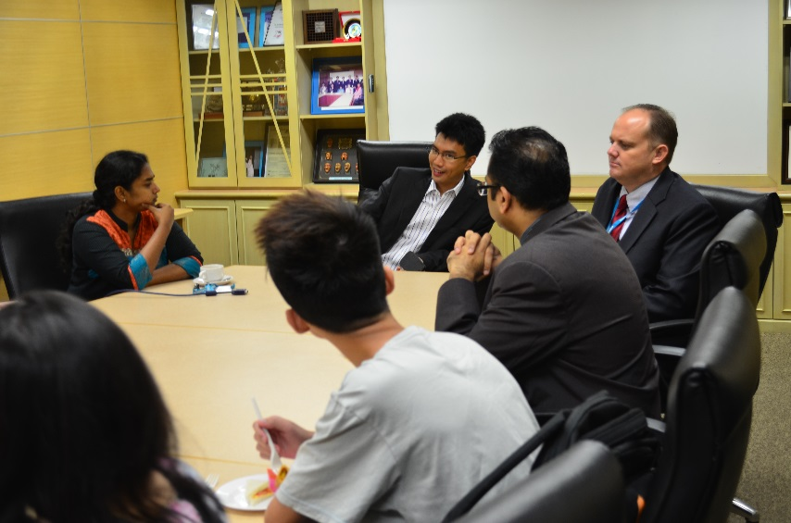

Dialogue Session with YAM Tunku Zain Al-‘Abidin Muhriz

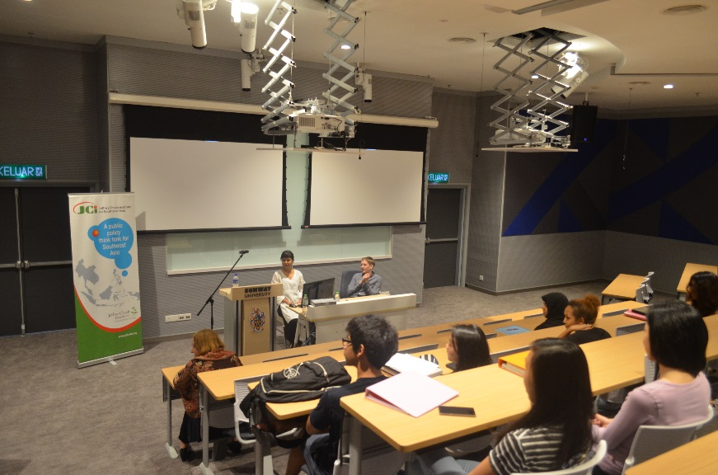

Guest Lecture & Dialogue Session with Damina Khaira & Seth Soderborg – PhD Candidates from Harvard University

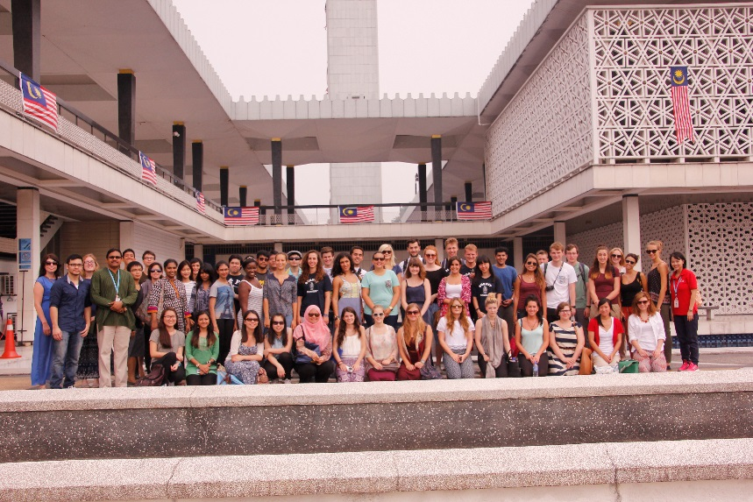

Trip to Religious Places in Malaysia with Lancaster University Students